***DSW PROJECT SYNOPSIS***

***Project Title:****ShopXSocial–shopping & selling made easy.*

***Project Description:****Our website provides two different profile options*

* *buyer*
* *seller*

***Buyer Profile:****After login/sign-up, the user will be directed to the homepage where they can view various shops & products posted by different sellers. The user can enter any shop, where he will be able to view the different products listed by the seller. The user can interact with sellers on the* ***messaging portal.*** *Users can make payment through the* ***payment portal****.*

***Seller Profile:****After seller’s sign up, he is given the option to post his shop on the website and add his products. To* ***add customers*** *to his shop, the seller can send requests to customers. He can* ***post*** *any new offers/products for his customers and to attract new customers. On his posts, he can receive likes and comments/reviews regarding his product.*

***Assumptions:****Buyer- seller will handle the transportation on their end and they will deal in wholesale only(Products are to be sold in bulk).*

***ER Diagram :***

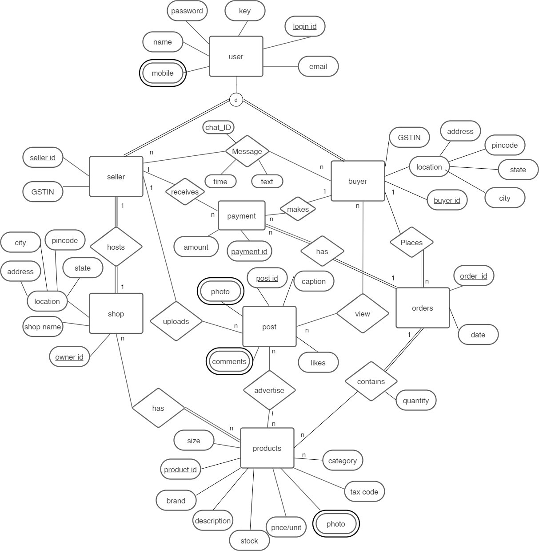

***Mapping***

***Tables :***

***USER TABLE***

|  |  |  |  |  |  |
| --- | --- | --- | --- | --- | --- |
| *Login ID* | *Password* | *e-mail* | *mobile* | *name* | *key* |

***SELLER TABLE***

|  |  |  |
| --- | --- | --- |
| *Login ID* | *Seller ID* | *GSTIN* |

***BUYER TABLE***

|  |  |  |  |  |  |  |
| --- | --- | --- | --- | --- | --- | --- |
| *Login Id* | *Buyer Id* | *GSTIN* | *State* | *City* | *Pincode* | *Address* |

***Products***

|  |  |  |  |  |  |  |  |  |  |  |
| --- | --- | --- | --- | --- | --- | --- | --- | --- | --- | --- |
| *Prod id* | *brand* | *Order id* | *Buyer id* | *price* | *desc* | *stock* | *photo* | *Size* | *category* | *Tax code* |

***Shop***

|  |  |  |  |  |  |
| --- | --- | --- | --- | --- | --- |
| *Owner id* | *Shop name* | *State* | *City* | *Pincode* | *Address* |

***Post***

|  |  |  |  |  |
| --- | --- | --- | --- | --- |
| *Post id* | *caption* | *photo* | *likes* | *comments* |

***Photos***

|  |  |
| --- | --- |
| *post_id* | *photo* |

***Comments***

|  |  |
| --- | --- |
| *post_id* | *comment* |

***Payment***

|  |  |  |  |  |
| --- | --- | --- | --- | --- |
| *Order id* | *Payment id* | *amount* | *Buyer id* | *Seller id* |

***Message***

|  |  |  |  |  |
| --- | --- | --- | --- | --- |
| *seller_id* | *Buyer_id* | *Time* | *text* | *Chat_id* |

***Orders***

|  |  |  |  |  |  |
| --- | --- | --- | --- | --- | --- |
| *Order_id* | *Date* | *Buyer id* | *Seller id* | *Product id* | *Quantity* |

***Group***

***Sarthak Gupta*** *(20103019)*

***Bhavey Mittal*** *(20103028)*

***Naman Gupta*** *(20103029)*

***Tushar Pasricha*** *(20103001)*